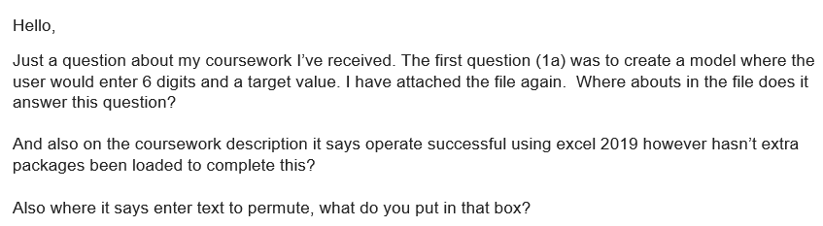

Answer to the first question (1a), I have created the model (use sheet 1 in excel file) where user click the button (i.e., permutation, smallest, and biggest) and the message or input box open. In this message box user give the six digits number and after that one more input required which is target value of the six digits. Once user provide correctly input in the message box, target value displays at the top in the same sheet of excel.

In the excel sheet, there are three buttons and these are automated with the help of VBA Macros which can employ Excel's Visual Basic application to build unique user-generated procedures and improve manual steps through the creation of automated workflows.

In order to avoid doing repetitive operations manually every time, you can automate procedures in Excel using macros. Time is saved throughout the automation process by using Excel macros, and trustworthy, high-quality work is produced. So, this is role of buttons and also buttons are easy to use.

For example, when you click on the “permutation button” then message box open, enter six digits like 345789 and the target value is 112. After that six-digit value which is already arranged, displays top of the excel sheet. The output value is 974835, now you can split the value into 3 digits such as 974 and 835, subtract it and you will get 112. In this way, macro button can be used. Apart form that, if user skip any one of the input boxes then it cannot run successfully and which means that you have to insert the number again.

On the other hand, the text “permutation” that I had putted in the box. So, it is just a name for a button and you can give any name whatever you want.